Practical - 9
Practical Title: 9: Secure User Registration with Database Insert, Duplicate Email Check, and Password Hashing

Problem Definition: Implement secure user registration by inserting user details into MySQL

using MYSQLi. Validate input on frontend and backend, check duplicate

email/username, hash passwords using password_hash(), and display

appropriate messages.

Theory

1. Is password_hash() used before storing passwords?
ANSWER: Yes, password_hash() is used before storing passwords.
The PHP function password_hash() is used to convert the original password into a secure hash before storing it in the MySQL database. Here, PASSWORD_DEFAULT is used, which selects PHP's default password-hashing algorithm. This ensures that the original password is not stored as plain text in the database.

2. Is duplicate email/username checked?
ANSWER: Yes, duplicate email is checked. If a duplicate email is found, an appropriate error message is displayed. Unique constraints on database columns provide additional protection against duplicate records.

3. Are frontend and backend validations consistent?
ANSWER: Yes, Both frontend JavaScript and backend PHP validate the username, email, password length, and password confirmation. Frontend validation provides immediate feedback to users, while backend validation ensures that invalid data is rejected even if browser-side validation is bypassed. Both layers follow the same validation rules.

Implementation/ Output/Result:

Evidence of Work (Screenshots):

The register form : (which includes username, e-mail and password, also confirm password for verifying it and it is used to convert it into secure hash)
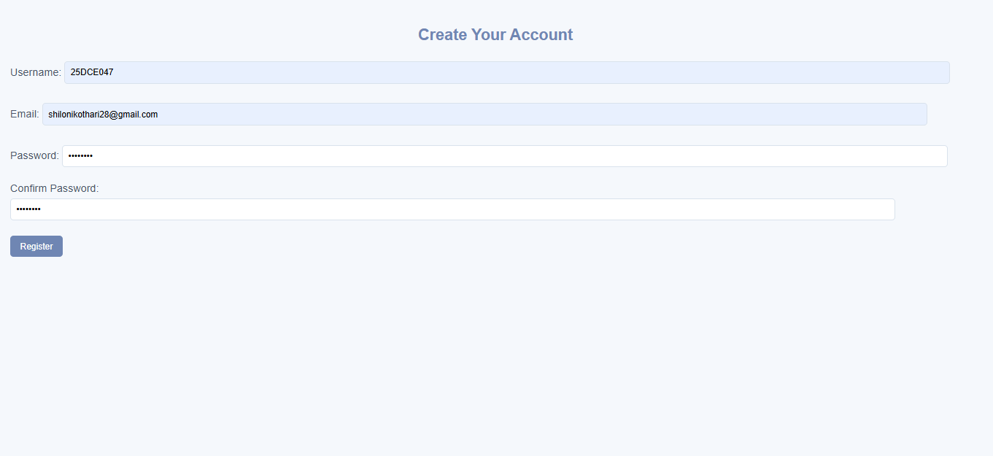

After entering correct and accurate details, the registration is done successfully.
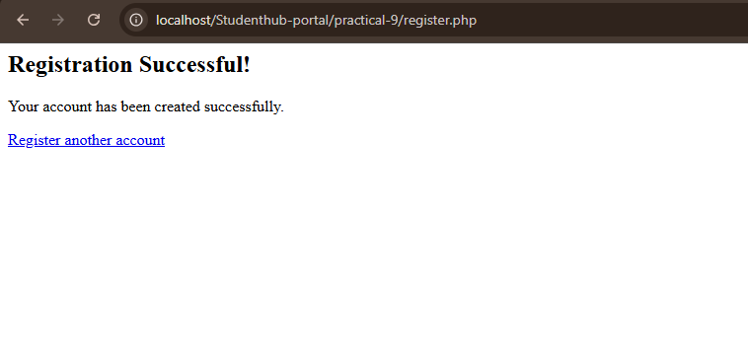

The entered data is seen into the Database:
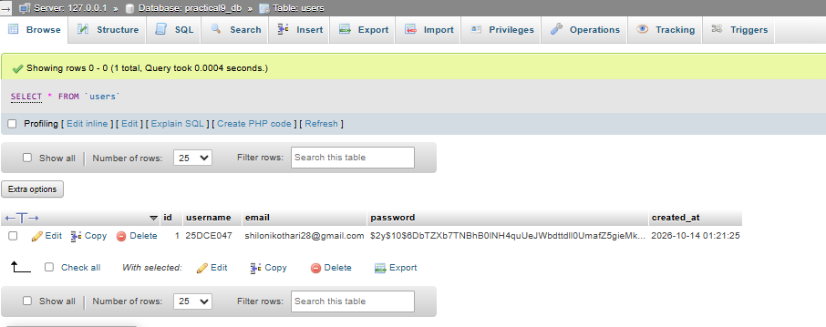

The username shouldn’t contain “.” So it shows error.
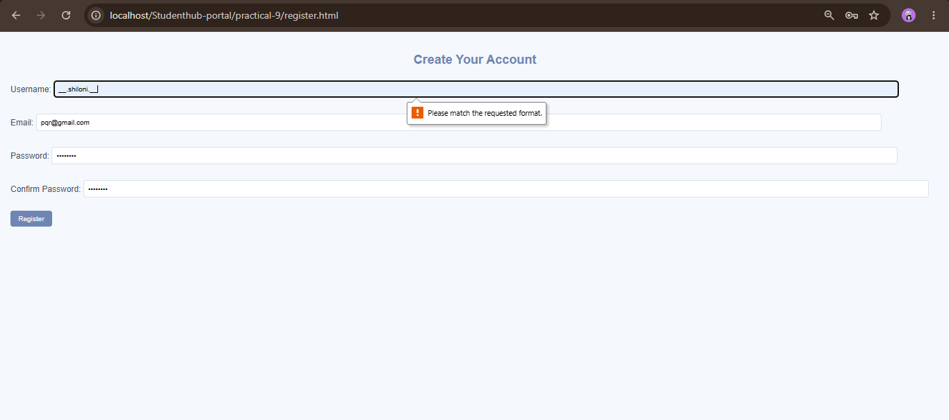

Entering the duplicate e-mail for the different username:
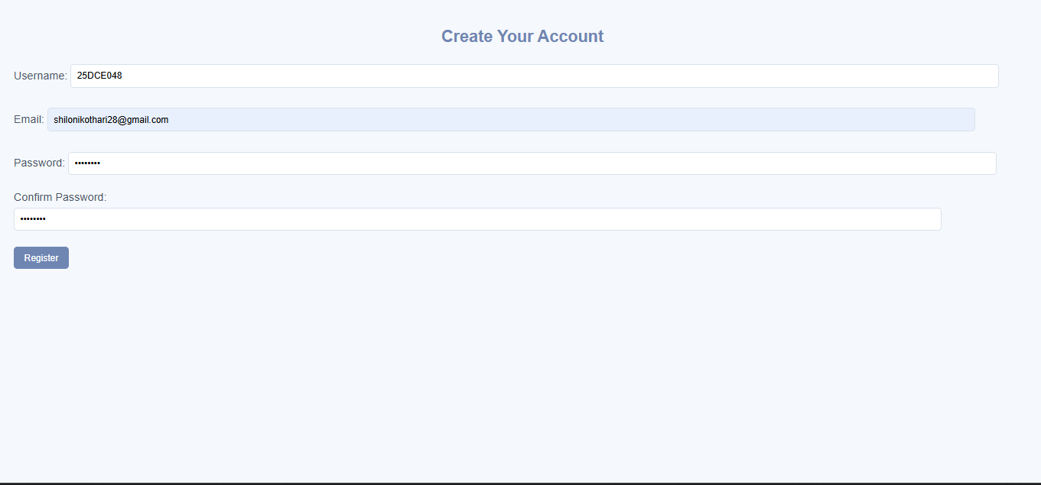

So it shows this message:
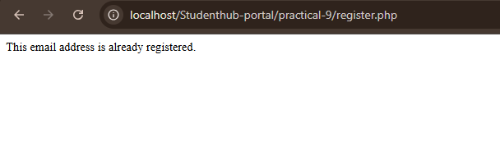

The invalid input of e-mail is given here:
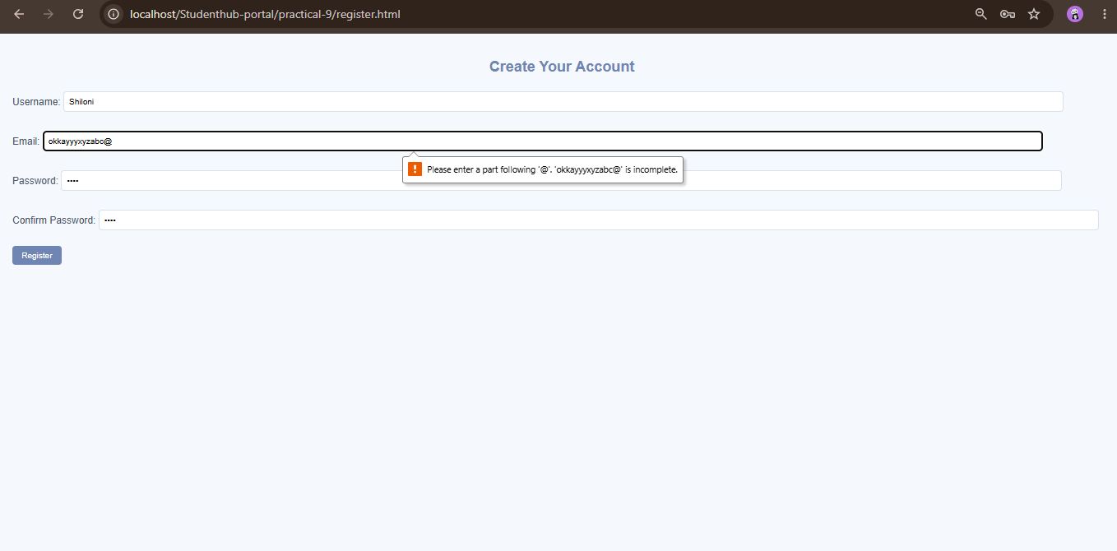

The password and the Confirm Password field doesn’t match.
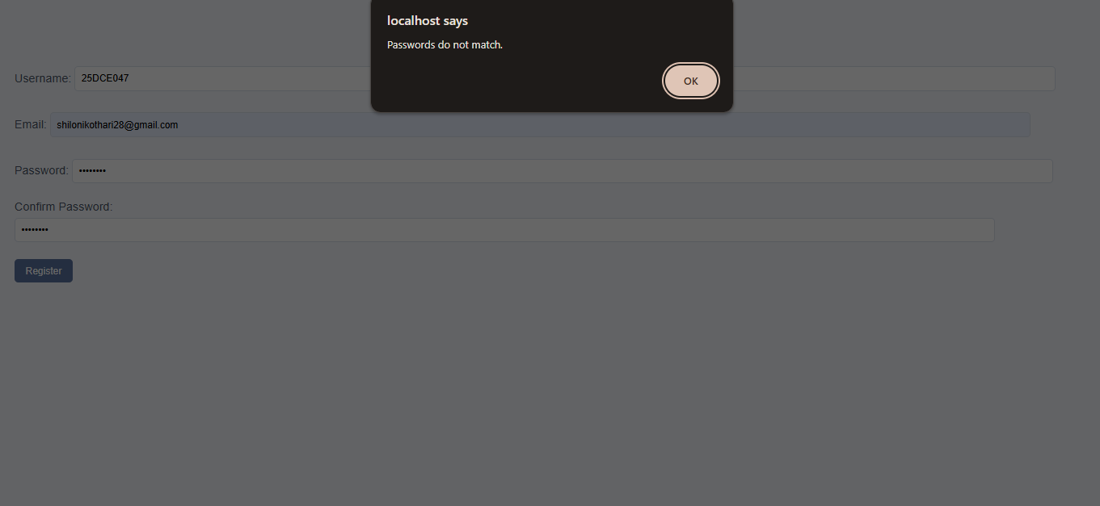

The password must contains 8 characters but here it has only 2 so it shows this message:
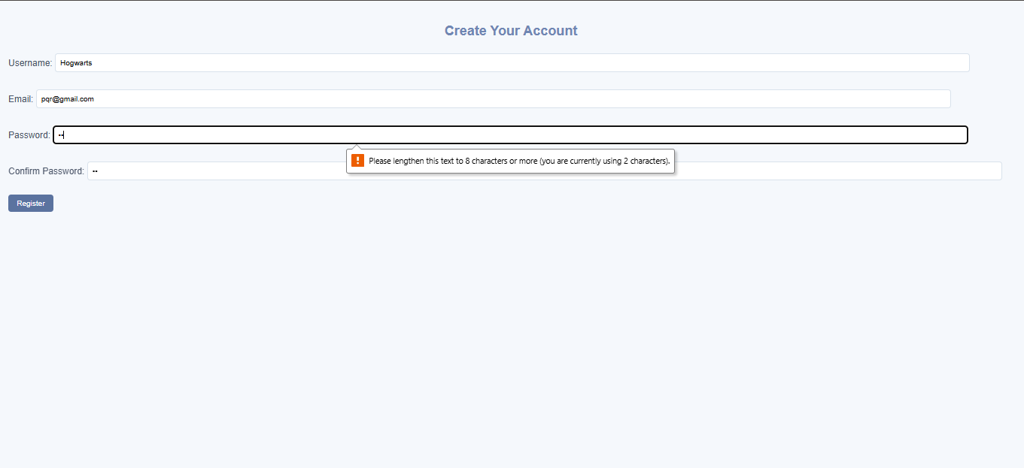

GitHub Repository Link:

https://github.com/shiloni28/WDF.git

E.Challenges Faced:

• Database connection: Configuring the PHP database connection with the correct database name and credentials.
• Input validation: Ensuring that username, email, password length, and password confirmation follow the required rules.
• Duplicate checking: Preventing users from registering with an email address or username that already exists.
• Password security: Understanding how to store password hashes instead of plain-text passwords.
• Database insertion: Using prepared statements to insert validated registration details safely into MySQL.
• Consistent validation: Ensuring that frontend JavaScript validation and backend PHP validation follow the same rules and produce appropriate error messages.

F.Learning Outcomes:

- Establish a database connection using PHP.
- Validate user inputs on both the frontend and backend.
- Check for duplicate usernames and email addresses before registration.
- Hash passwords securely using password_hash().
- Use prepared statements to reduce the risk of SQL injection.
- Insert user registration details into a MySQL database.
- Display appropriate success and error messages for valid, invalid, and duplicate registration attempts.
- Also learnt to convert the password into secure hash before storing it into the Database.

Faculty Remarks:

